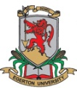 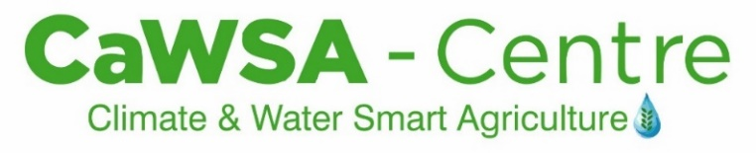

Community & Student Engagement Practical Training Centre

The Problem

Climate change is real as seen in erratic rainfall patterns, increasing temperatures, frequency of droughts, floods and food shortage. Research has shown that farmers and communities can mitigate climate change and improve their resilience by improving their micro-climate. Reversing climate change must start with each one of us using the Community Managed Disaster Risk Reduction (CMDRR) and the Community Action Research Project Plus (CARP+) models.

The Solution

Water harvesting and storage for use in Irrigation water provides great opportunities for growth and development in the agriculture sector of Kenya. With only 3 m3 water use/capita/year, Kenya has one of the lowest surface water storage rates in the world for irrigated agriculture and livestock use. (ICRAF 2012). By 2013, only 12% (161,840 ha) of the irrigation potential had been developed (Water Master Plan, 2012). To realize this huge potential, more investment in Smart Water Solutions for agriculture are needed by all agricultural actors, i.e., farmers, the state, and private sector (e.g., SWS inputs & technology providers, market off takers and financial service providers). Conservation agriculture and climate smart farming practices are important strategies.

With support of SNV Kenya, Nakuru County Government, MasterCard Foundation, RUFORUM, Equity Foundation, ECLOF Kenya, Sun Culture, Lachlan Africa, Frigoken (IPS), ADC, Stockman Rosen/CIP and other partners, the **Nakuru Irrigation Platform** and the **Seed Potato Value Chain** (SPVC) **Community Action Research Project *Plus***(CARP+) established the **Climate and Water Smart Agriculture Centre (CaSWA-C)** in January 2019. The purpose of the CaWSA-Centre is to be a centre of excellence on climate and water smart technologies, innovations and management practices (TIMPS). In March, Egerton University was selected and awarded a competitive seed grant from SNV Kenya to expand the centre. The CaWSA-Centre will provide training on water use and conservation for crops and cropping systems.

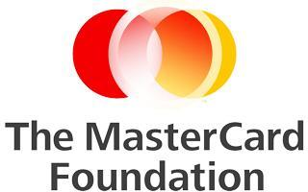



Our Facilities & Services

The CaWSA-C houses the Nakuru Irrigation Acceleration Platform secretariat and facilitates development of the Irrigated value chain (IVC). It promotes systematic water towers and lake basins water conservation and use in Nakuru County through farmer and students’ trainings, field days, exchange visits, business-2-business meetings, input and output markets development and policy dialogue.

It also implements the Seed Potato CARP+ project in partnership with farmers and stakeholders. It convenes the Nakuru potato platform that is mobilizing farmers to form strong and inclusive producer organizations and a County level cooperative union. The centre contributed to development of the Nakuru County potato strategy, 2019 Irish potato regulations and set up of county potato demonstration units and farmer training and empowerment.

Our facilities and services include:

1. Secretariat of the Nakuru Irrigation Acceleration platform and CARP+ project
2. Farmers CaWSA resource and outreach centre offering:

* Demos on water harvesting pans, solar pumps, drip, mist and sprinkler irrigation systems
* Farmer and student-led crop and fodder demonstration and experimentation plots
* Hydroponic, aeroponic and mechanized seed potato demonstration units
* Short Courses, seminars, demo farm tours
* Grow and sell crops to generate income to sustain centre, IAP and projects

1. Support farmer outreach, training and producer organizations strengthening

Partnership Opportunities

This is a private sector and famer-led initiative to provide cutting edge skills for students and farmers to enable them engage in commercial agriculture while improving their resilience to climate change.

Contact us:

Prof. Anthony M. Kibe, CaWSA – Centre Coordinator

Agronomy Training Field 7 & 17, Egerton University, Njoro, Kenya

Email: [akibe@egerton.ac.ke](mailto:akibe@egerton.ac.ke), +254721402957

**IAP@Nakuru**: [irrigationplatform.nakuru@egerton.ac.ke](mailto:irrigationplatform.nakuru@egerton.ac.ke), 0700303602

**Seed Potato CARP+**: [carp.potato@egerton.ac.ke](mailto:carp.potato@egerton.ac.ke), 0721103669

**CaWSA-C**: [nakuru.iap@gmail.com](mailto:nakuru.iap@gmail.com), 0722897912

